

Blog

Summary

Use case diagram 3

Sequence diagram: contact blog owner 4

Sequence diagram: add comment 5

Sequence diagram 6

Class diagram 7

Use case Diagram
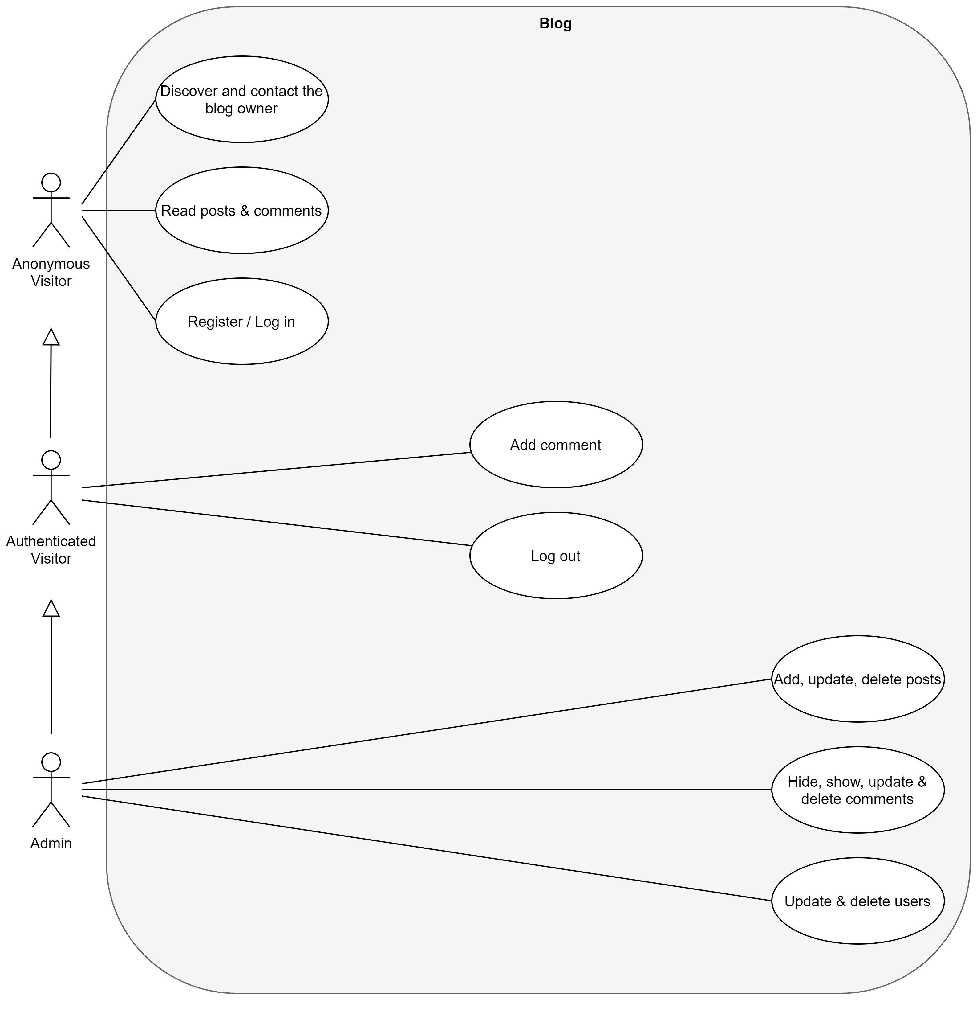

Sequence diagram: contact blog owner
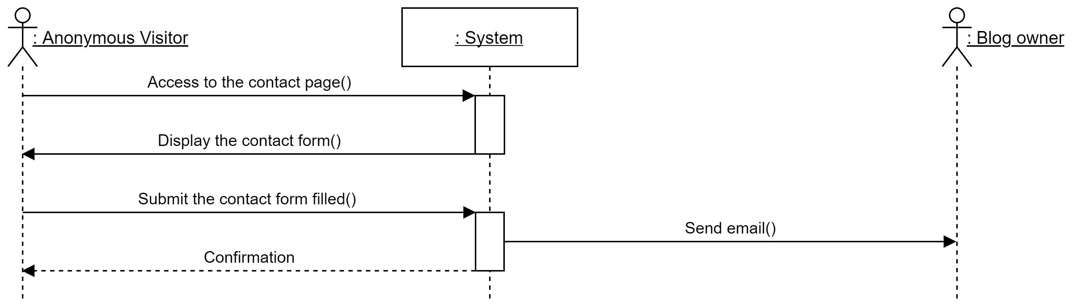

Sequence diagram: add comment

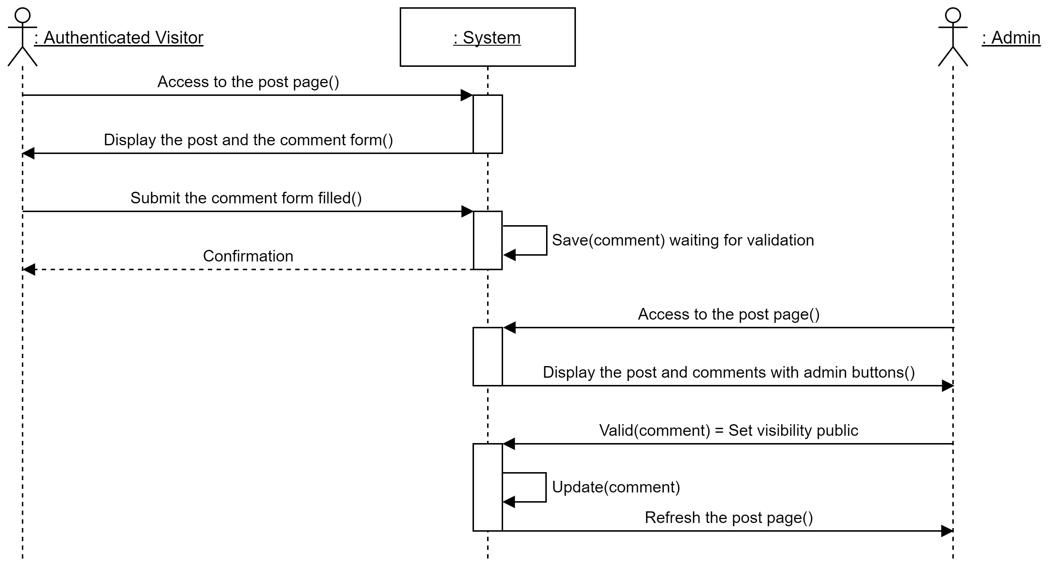

Sequence diagram: admin registration
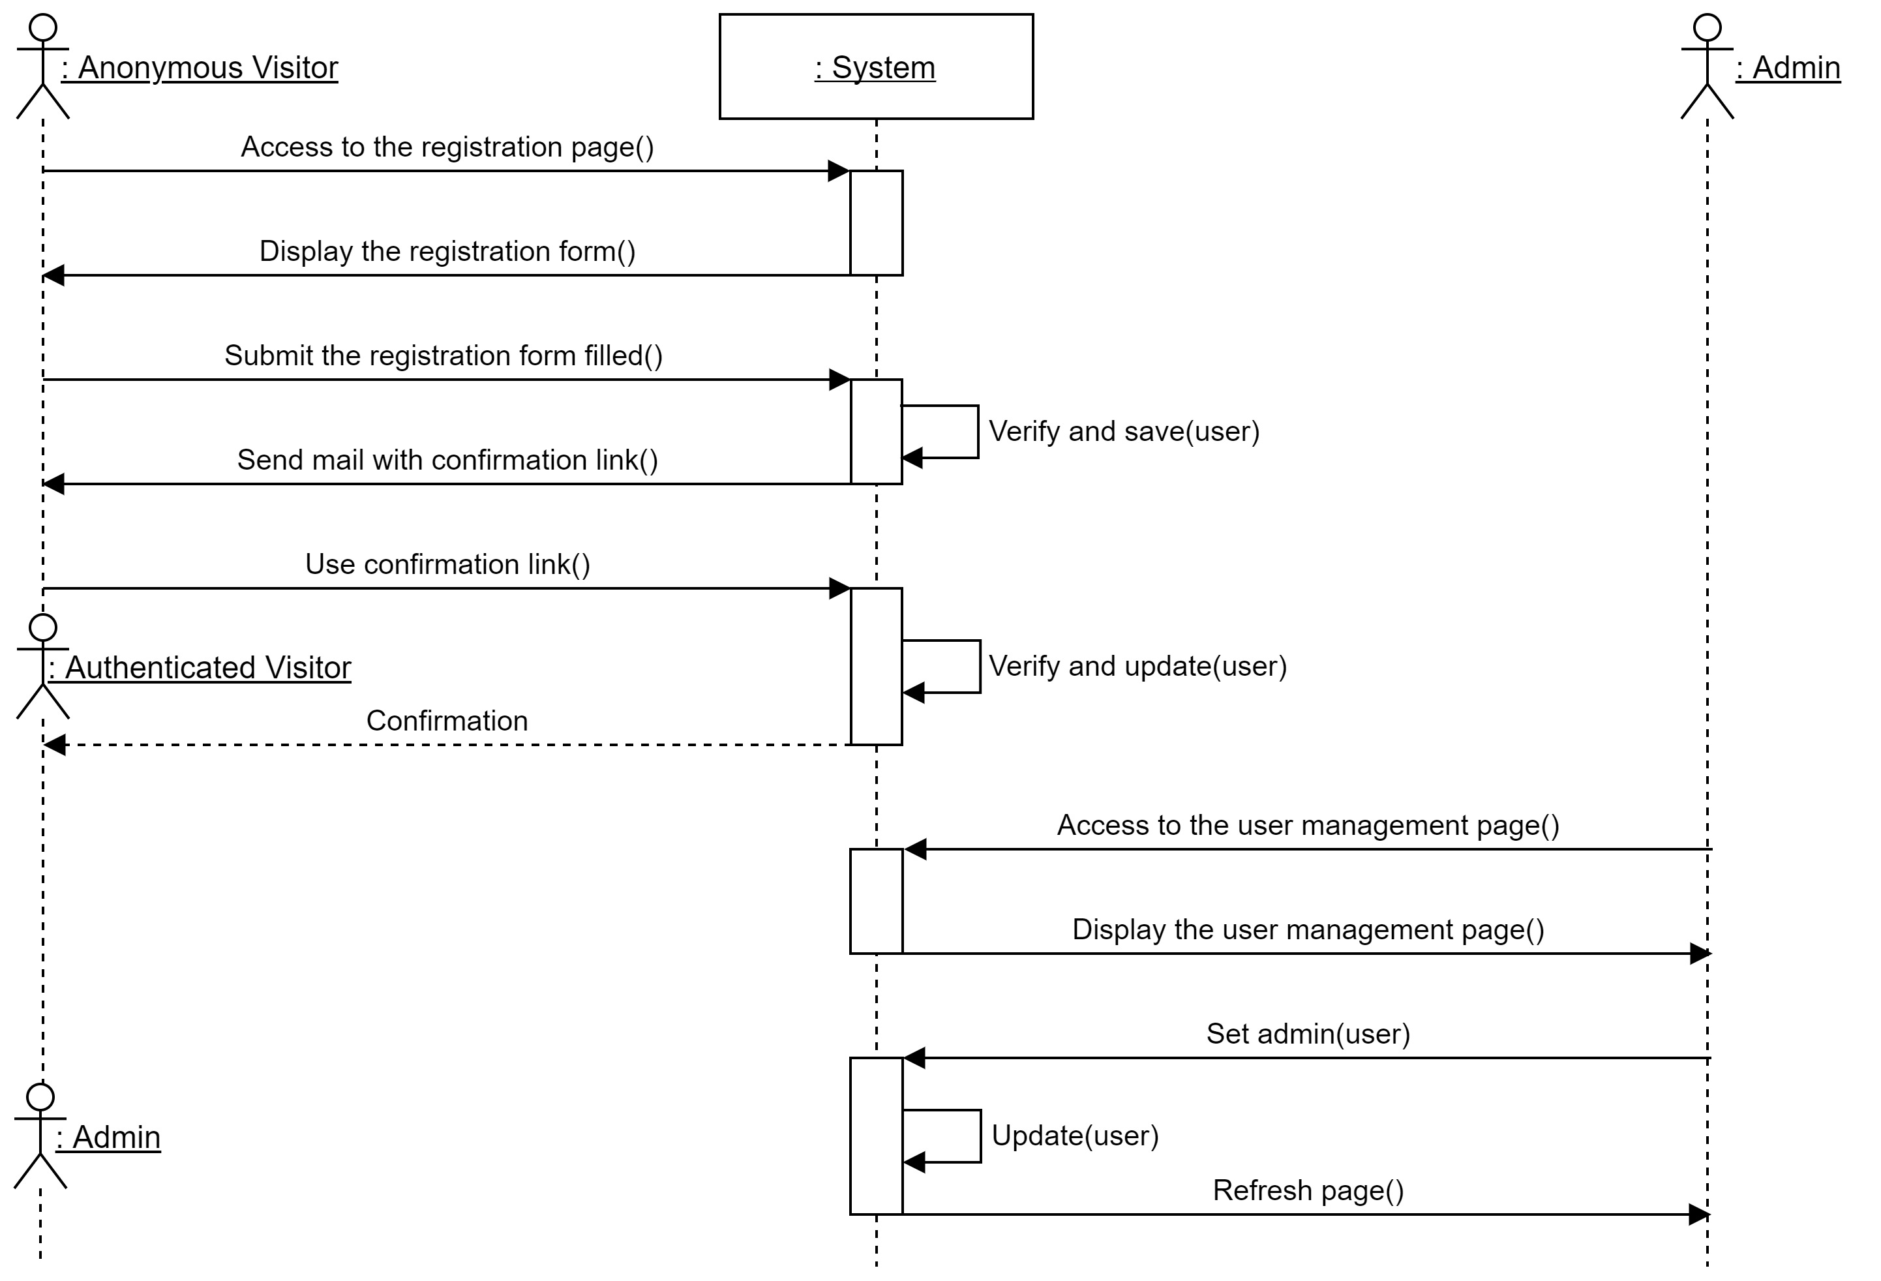

Class diagram

